ENTRY FORM

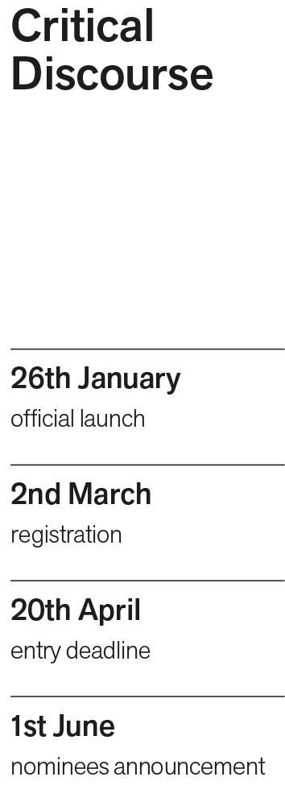
Name: ...............................................................
Surname: .........................................................
Gender: ............................................................
City and country: ...........................................
The subject of the essay (maximum 250 characters, spaces included):
.............................................................................
Occupation, working at (if the case): .............................................................................
Occupation, studying at (if the case): ............................................................................
Contact details (email, phone number): ............................................................................
Permanent address (for possible correspondence - optional): ........................................................
How did you find out about the contest? ...........................................................................

