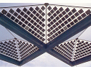

European Symposium on

Renewable Energy in
European Universities of Architecture

on Thursday 25 and Friday 26 October 2007

UNIVERSITATEA DE ARHITECTURA SI URBANISM "ION MINCU"
UNIVERSITE D'ARCHITECTURE ET URBANISME "ION MINCU" –
"ION MINCU" UNIVERSITY OF ARCHITECTURE AND URBANISM
Strada Academiei 18–20, Telefon: 3077159. 3077133. Fax: (40) 1 312.39.54, 410010 BUCURESTI, ROMANIA
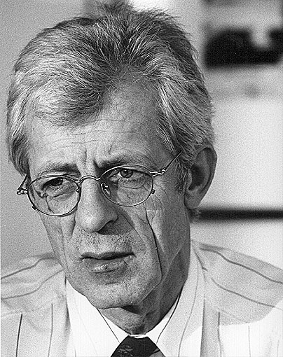

Special guest of the Symposium is Prof. Em. Dr. Eng. e.h. Klaus Daniels,
professor at ETH Zurich – Dep. Architecture, director of HL – Technik Engineering Partner GmbH and HL – Beratungs – und Beteiligungs GmbH Munich, author of important studies in domain

